Dear New LSUS Student-Athletes,
Prior to participating on a team at LSUS, student-athletes must provide the Athletic Training Department with current address, emergency contact, insurance, medical alert and health history information. To expedite this process LSUS uses an online data entry system.
To enter your information, visit www.swol123.net. The first time you visit the website you will need to enter your email address and click Get Password.

Joining SportsWareOnLine (SWOL)
Instruction | Example
Go to www.swol123.net. | 
Look on the right side of the screen and click the Join SportsWare button. | 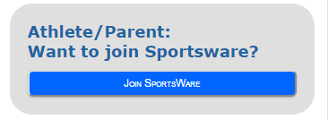
Enter your School ID:  LSUSPilots  NOT your numerical School ID | 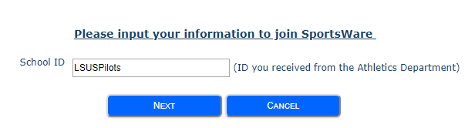
Enter your  - First Name  - Last Name  - Email address (if another school had this system use another email address)  - Group: Select LSUS  Click the Send button. | 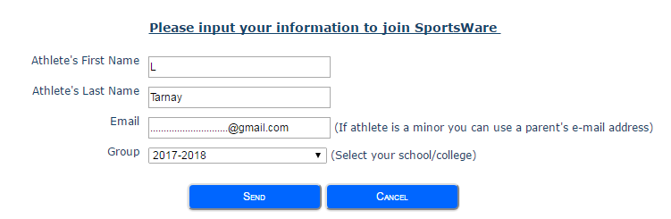
Your request to join SportsWare will then be sent to the Athletic Trainer for review. | 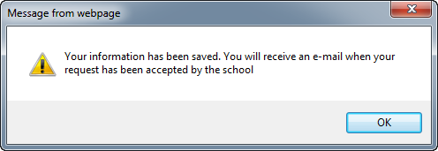

*It may take time for your request to be accepted so please be patient*
Once your request is accepted log onto your email and you will receive an e-mail with the Subject “SportsWare request accepted”. If you did not receive an email check your SPAM folder.  Open the e-mail and click the link to continue to SportsWare OnLine to set your password. Enter your e-mail address, new password and click the Save button. |   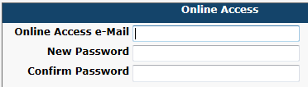

Updating Your Information
Instruction | Example
Go to www.swol123.net
Enter your Email Address & password then click the Login button.
This is your dashboard; complete all forms and all tabs in order to be cleared to play  Forms (6):  - Acknowledgement of Assumption of Risk and HIPAA  - Acknowledgement of Insurance Information  - Acknowledgement of Insurance Policy and Procedure  - Acknowledgement of ATR Rules  - Concussion Acknowledgment  - Drug Testing Consent  Click SUBMIT and SAVE, if you do not complete all required fields it cannot be submitted and are therefore not complete.  My Info: Complete the following tabs:  - General  - Address  - Emergency  - Insurance  - Upload Insurance Card  - Medical  Complete all fields with an asterisk (*)  Medical History: Complete Medical History questionnaire. Explain ALL answers marked with a YES response | 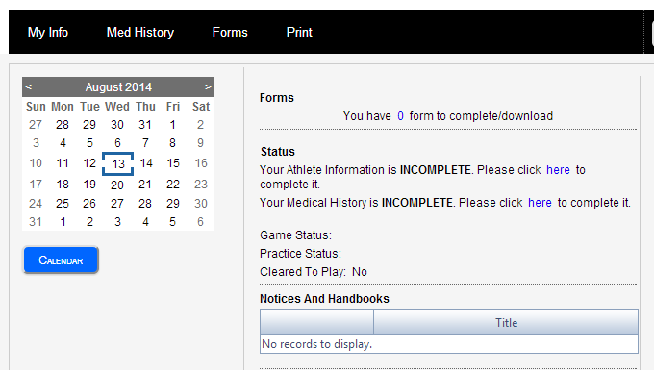  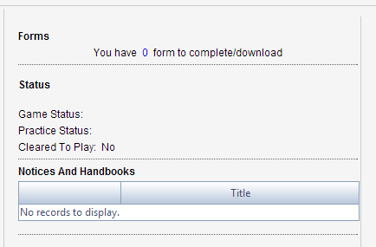
COMPLETE= “0 Forms to be completed” and there are no “Incomplete” forms under Status
You can always sign onto SportsWare to check your status, just click “MY INFO” tab, click “PAPERWORK” and view your status.
Instruction | Example
Under General tab:  - SSN-if you don’t have one put your School ID # in the ID section and put N/A in SSN  - For Class choose anticipated date of graduation from drop-down list  - Senior: 2027  - Junior: 2028  - Soph: 2029  - Fresh: 2030  Click SUBMIT and SAVE, if you do not complete all required fields it cannot be submitted and are therefore not complete. Complete all fields with an asterisk (*) | 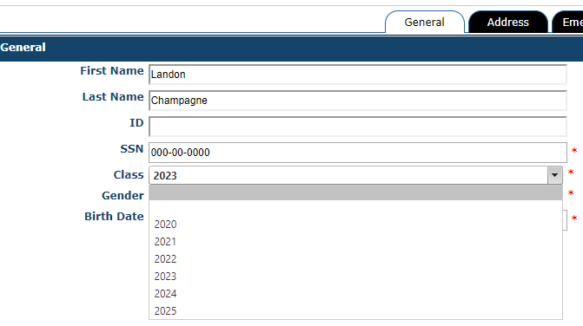
Under Insurance tab:  - Complete to the best of your abilities for student-athletes that have insurance.  - If you have a State Medicaid policy put the State Abbreviation and Medicaid in parentheses after the company name. Ex (LA Medicaid)  - Please upload an insurance card  Click SUBMIT and SAVE, if you do not complete all required fields, it cannot be submitted and are therefore not complete. | 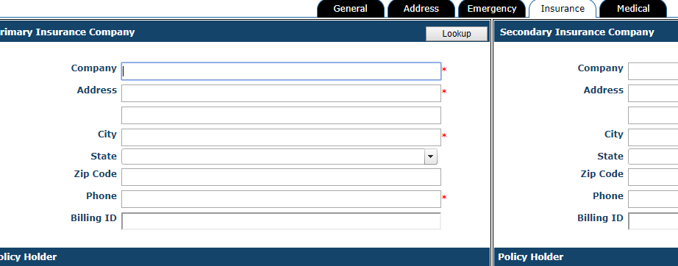
Under Medical tab:  - Fill out all known allergies and/or alerts!  - Use the drop-down list like the picture below or type in the box with your known allergies and/or alert.  - Click none from the drop-down list if you do not have any allergies or alerts.  Click SUBMIT and SAVE, if you do not complete all required fields, it cannot be submitted and are therefore not complete. |   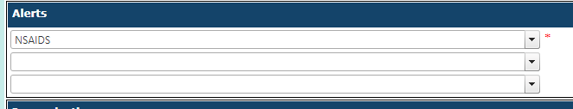  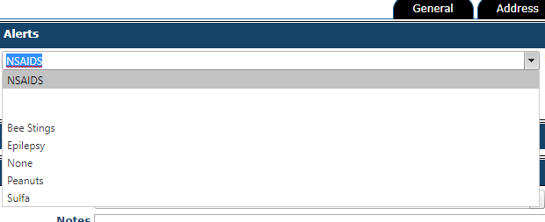
Under Med History tab:  - Complete to the best of your abilities  - If marked Yes, explain in the comment section.  Click SUBMIT and SAVE, if you do not complete all required fields, it cannot be submitted and are therefore not complete. | 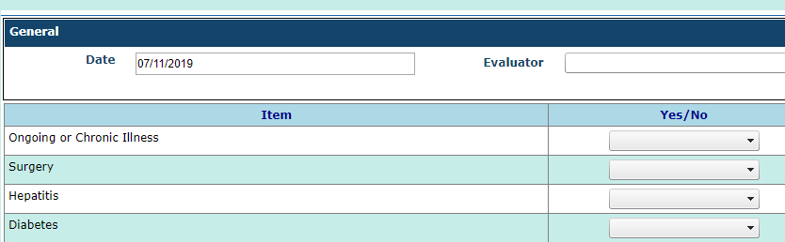  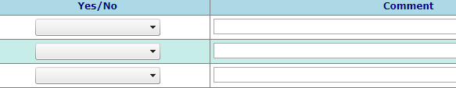

What do I need to do once my account is set-up?
There are 6 forms that must be signed.
- Acknowledgement of Assumption of Risk and HIPAA
- Acknowledgement of Insurance Information
- Acknowledgement of Insurance Policy and Procedure
- Acknowledgement of ATR Rules
- Concussion Acknowledgment
- Drug Testing Consent

After signing all forms, there are 2 more sections that must be filled out:
Athlete Information- All 5 sections must be completed along with the Medical History
- General
  - SSN-if you don’t have one put your School ID # in the ID section and put N/A in SSN
  - Grad Class (When you intend to Graduate, ex. 2026)
- Address (Primary -School Address) (Secondary – Home address)
- Emergency
- Insurance (Must Upload Front and Back of Insurance card)
  - International Insurance: Make sure it’s the original card not temp card or proof of purchase)
- Medical

Medical History
- All questions must be answered and please provide descriptions to questions answered “yes”.
To be cleared for athletic participation, all paperwork must be submitted and approved by the athletic training staff.
Please note, you will not have access to SportsWare Online until the athletic training staff approves you.
Thank you for your prompt help. If you have any questions, please contact the athletic training staff for assistance.
Sincerely,
LSUS Athletic Training

